Simon Light

[Email address]

PDP

Unit 1 Assignment 3

Contents

P7. 2

Qualifications 2

Strengths and Weaknesses 2

Goals 3

Short term 3

Mid term 3

Long term 3

P8. 4

Qualifications 4

Strengths and Weaknesses 5

Goals 6

Short term 6

Mid term 6

Long term 6

Progress 6

30/09/2015 6

17/10/2015 6

10/11/2015 6

M3. 7

The test 7

The results 7

D2. 8

# P7.

## Qualifications

GCSE’s:

* A – Maths
* B – Double science, English Lit and Lang, Business, Drama, IT
* C – Spanish

A-levels (currently studying):

* Computer Science
* BTEC IT Level 3
* Maths
* Product Design

Extracurricular:

* Level 2 canoe and kayak
* 2 start award Cadets
* Green Card award – RCC

## Strengths and Weaknesses

|  |  |
| --- | --- |
| Ability | September rating |
| Technical Knowledge | 6 |
| Working Procedures | 5 |
| Team Working | 7 |
| Numeric Skills | 7 |
| Creativity | 5 |
| Determination | 4 |
| Independence | 6 |
| Integrity | 4 |
| Tolerance | 7 |
| Dependability | 7 |
| Problem Solving | 8 |
| Leadership | 5 |
| Confidence | 6 |
| Self-Motivation | 6 |

## Goals

### Short term

* Get a distinction Unit 1
* Revise for all of the upcoming progress tests
* Get fully trained at work
* Get my team selected for the PBA project

### Mid term

* Save enough to learn to drive
* Get a MOS
* Build a new Computer with a 3 screen set up

### Long term

* Pass A-Levels
* Seek an IT Apprenticeship
* Be self-reliant

# P8.

## Qualifications

GCSE’s:

* A – Maths
* B – Double science, English Lit and Lang, Business, Drama, IT
* C – Spanish

A-levels (currently studying):

* Computer Science
* BTEC IT Level 3
* Maths
* Product Design

Extracurricular:

* Level 2 canoe and kayak
* 2 start award Cadets
* Green Card award – RCC

## Strengths and Weaknesses

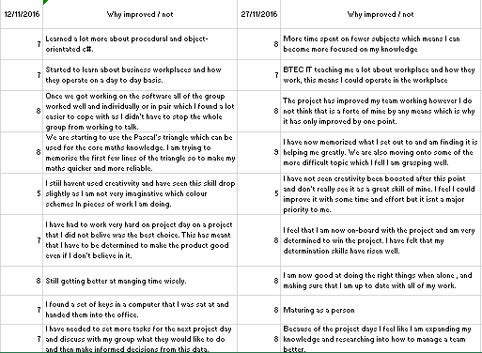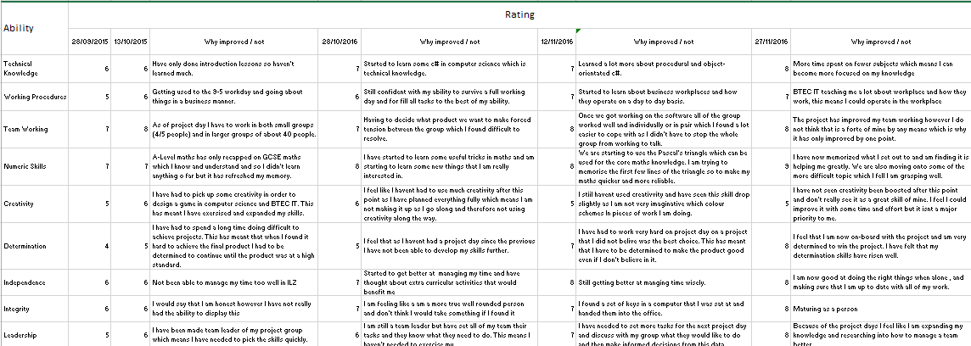

## Goals

### Short term

* Get a distinction Unit 1
* Revise for all of the upcoming progress tests
* Get fully trained at work
* Get my team selected for the PBA project

### Mid term

* Save enough to learn to drive
* Get a MOS
* Build a new Computer with a 3 screen set up

### Long term

* Pass A-Levels
* Seek an IT Apprenticeship
* Be self-reliant

## Progress

### 30/09/2015

* Have updated this report
* Started revising computer science
* Have finished my last trainee shift
* I pitched to the project leader of the PBA project

### 17/10/2015

* Achieved distinction in this assignment without any corrections.
* Created a plan on what I need to save money for so that I can manage it more effectively
* Fully revised for all progress tests

### 10/11/2015

* Started to move money into a savings account to achieve higher interest rates
* Completed all training for outlook MOS and am just waiting to take the test
* Have made a plan on my pc set up and have got three screens.
* Have been working hard on all of my A-level courses
* Looked into apprenticeships at GCHQ and other security companies.

# M3.

Learning styles depict the way that an individual is best suited to learning. This is split up into the following three categories:

* Kinaesthetic – learns by doing/touching (e.g. class activities and projects)
* Visual – Learns by seeing things (e.g. watching movies of activities and projects)
* Auditorial – Learns by listening (e.g. someone talking about experiences)

Knowing what type of learning style you are means that you can tailor your tuition towards it. Doing this will result in less time being spent learning topics as you are able to pick it up much quicker. Although learning styles are split into these three main categories you are not required to fit into one of them. You can find yourself being two/three of them and even changing on a day to day basis.

There are a lot of learning styles tests on the internet. Their goal is to give you a better understanding of your brain and the way it works. I am going to take one of these tests and share my results and then explain what this means to me.

## The test

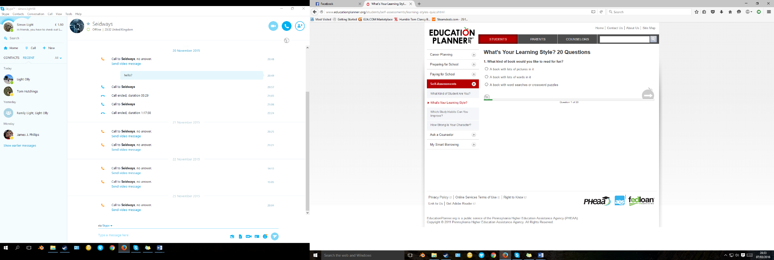After looking through a few websites I settled on a 20 question style test from education planner. I understand that this is not going to be the most in depth test but it should show some clear results. The test gave different scenarios and three different options. It was quite clear to see that each question was one of the learning styles but I tried to answer impartially to get a fair result.

## The results

The test resulted in me being a tactile/kinesthetic learner. This was the result I expected however I dint expect myself to be 25% visual. From this I know that the excercises I do need to mainly focus on doing things but also looking/reading things.

Some things that will aid my learning include:

* Participate in activities that involve touching, building, moving, or drawing.
* Do lots of hands-on activities like completing art projects, taking walks, or acting out stories.
* It's OK to chew gum, walk around, or rock in a chair while reading or studying.
* Use flashcards and arrange them in groups to show relationships between ideas.
* Trace words with your finger to learn spelling (finger spelling).
* Take frequent breaks during reading or studying periods (frequent, but not long).
* It's OK to tap a pencil, shake your foot, or hold on to something while learning.
* Use a computer to reinforce learning through the sense of touch.
* Watch recording of lectures/lessons
* Read up on the topics that I am studying

Doing the above will result in my productivity being increased massively.

# D2.

My PDP will need improvement. This will happen when I advance as a person, both on a skill level and social level. To do this I will follow the acronym SMART. This stands for:

* Specific – Make your goal precise and specific.
* Measurable – Make sure that you can show at the end how much you have done.
* Attainable – Make sure that it is a goal that you can show that you have achieved it.
* Realistic – Is it actually do able?
* Time – Set a time period for you to complete this goal.

Following this acronym will mean that your PDP will be very descriptive and informative to your employer. It will also mean that you will actually be able to compete your goals and get you to advance in your skills.

An example of a goal I have at the moment that doesn’t for fill this task is “revise all of the upcoming tests”. This doesn’t follow the acronym. The way that I would change this is by saying “fully read over all notes done in class on the following maths, computer science and decision and achieve over 70%. This does follow SMART and so it is a better goal.

Some of the things I will need to change in my PDP are things that will become outdated. These could be things such as your goals (if you have completed these they don’t need to be on the PDP anymore), qualifications and skills (these can be lost and gained so need to be edited accordingly).